Trade Gaps Effects on Generating New Job Opportunities

Title-

How the countries’ natural imbalance of imports and exports effects on countries job market.

Abstract-

This paper provides an historical perspective on the recent behavior of the Sri Lankan trade deficit. Judged by historical experience, the trade deficit has reached what is a now unprecedented level. That unprecedented deficit has its principal source not in changes in market structure affecting the speed with which quantities respond to prices but in the policy environment, namely the monetary-fiscal policy mix. While other industrial countries have run comparable merchandise trade deficits at various points in the past, these countries either financed their deficits out of interest earnings on prior foreign investments or through the large—scale export of services, or used the debt they incurred to finance investment in infra- structure and to expand their capacity to export. Neither of these scenarios has a counterpart in current Sri Lankan experience. How easily can the trade deficit be eliminated if historical experience is a guide? Typically, the rapid reduction of deficits has been achieved through the reduction of imports; this typically entails restraints on aggregate demand from which recession results. Trade deficits have been reduced most quickly and at lowest cost when at least one of two conditions prevails: a favorable shock to the terms of trade or a reallocation of resources toward investment in export-oriented sectors. The first of these conditions is largely beyond the authority’s control while the second must be initiated well in advance. Barring a fortuitous terms—of—trade shock, this does not give cause for optimism that the conditions are present for rapidly eliminating the Sri Lankan trade deficit at low cost.

Introduction-

Body of Paper-

2010 report;

Sri Lanka’s economy grew by an impressive 8.0 per cent in 2010, reflecting a fast recovery from the setback suffered in 2009 and moved to a high and sustainable growth path. All key sectors of the economy demonstrated a commendable performance in 2010, underpinned by the peaceful domestic environment, and improved investor confidence, favorable macroeconomic conditions and gradual recovery of the global economy from one of the deepest recessions in history. Benign inflation and the favorable inflation outlook enabled the Central Bank to continue its accommodative monetary policy stance with further moderation of interest rates in all market segments supporting economic activity.

According to the Central Bank of Sri Lanka, the number of employed persons increased marginally by 1.4 per cent to 7.71 million in 2010 as compared to 7.60 million in 2009. This could be attributed to the growing demand for employment consequent to the improved performance in all three major sectors of the economy.

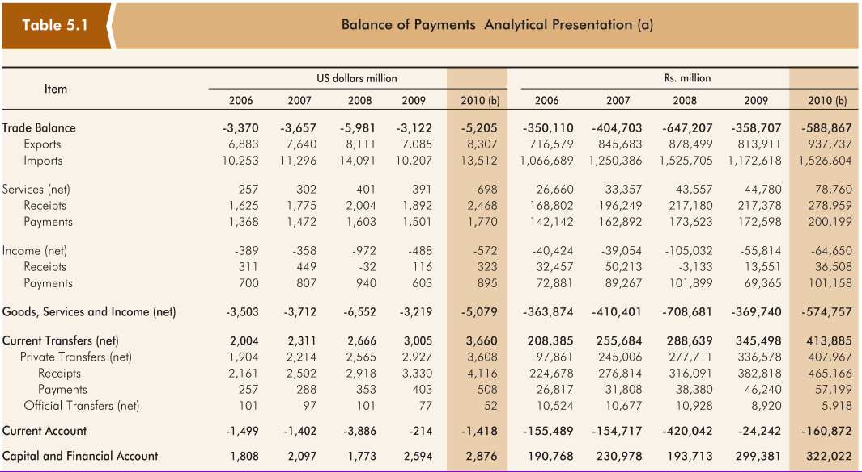

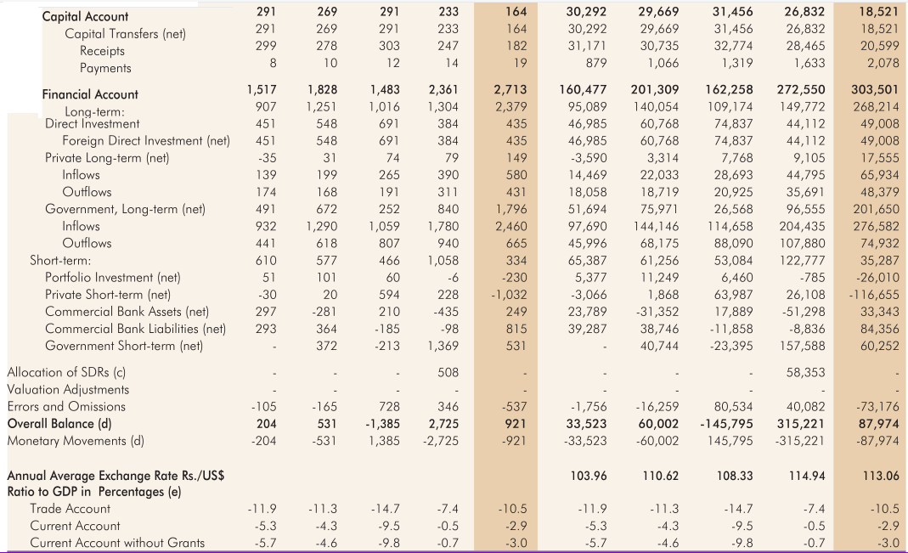

Source-Central Bank of Sri Lanka 2010 chapter 5

Trade balance means the difference between the Exports and Imports of a year.

According to the Central Bank report on 2010 we can see the following information on Trade gap.

**Trade Balance -588,867**

Exports 937,737

Imports 1,526,604

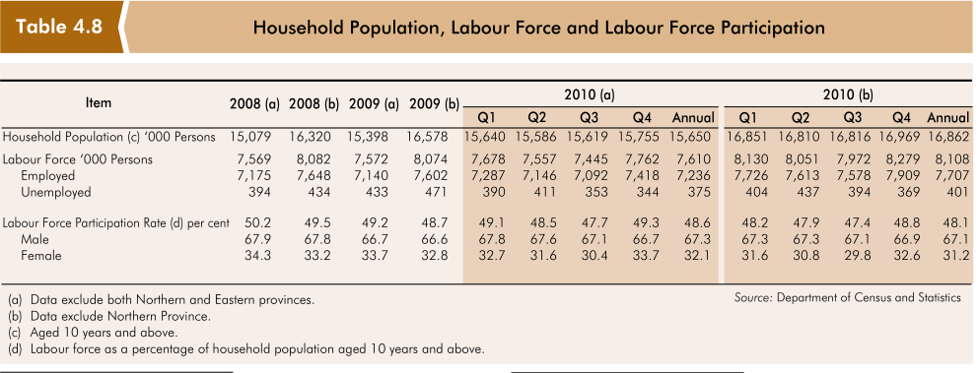

According to the above graph from central bank report of 2010, we can easily calculate the new jobs created trough out the year.

|  |  |  |  |
| --- | --- | --- | --- |
|  | 2009 | 2010 | New Jobs created |
| Employed  Labor Force (# of Persons) | 7,140,000 | 7,236,000 | 96,000 |

This can be further analyzing by dividing those new jobs in to 3 sectors.

1. Agriculture Sector
2. Industry Sector
   * + - 1. Manufacturing
         2. Construction
3. Service Sector
   * + - 1. Trade and Hotel
         2. Transport , Storage and communication
         3. Finance , Insurance and real state
         4. Personal services

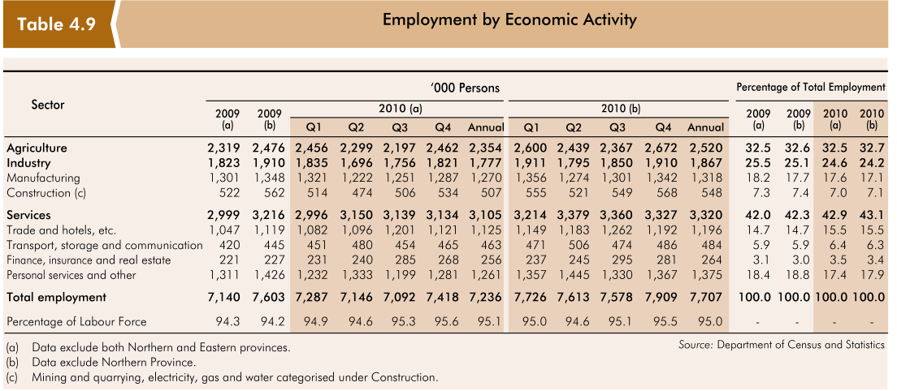

2009 2010 difference 2009 2010 percentage difference

Agriculture 2319 2354 35 32.5 32.5 0.0

Manufacturing 1301 1270 -31 18.2 17.6 -0.6

Construction 522 507 -15 7.3 7.0 -0.3

Trade 1047 1125 78 14.7 15.5 0.8

Transport, 420 463 43 5.9 6.4 0.5

Finance, 221 256 35 3.1 3.5 0.4

Personal 1311 1261 -50 18.4 17.4 -1.0





Here we can clearly see that all the jobs which created in the 2010 are created mostly by the Service sector. Number of jobs in industry sector is reduced by -0.9% (see conclusion) while the jobs percentage in agricultural sector remain unchanged.

New Job Opportunities in 2010



|  |  |  |  |
| --- | --- | --- | --- |
| New Jobs | Year 2009 | Year 2010 | difference |
| Agriculture | 2319000 | 2354000 | 35000 |
| Trade | 1047000 | 1125000 | 78000 |
| Transport, | 420000 | 463000 | 43000 |
| Finance, | 221000 | 256000 | 35000 |

According to the data that we extract from the central Bank report we can see only agriculture and service sectors are the only contributors for new job opportunities. Number of Jobs in the Manufacturing sector in contracted. So it created a negative effect on creation of new job opportunities.

In overall, the trade gap in Sri Lanka is **(**-588,867) LKR and 96,000 new jobs created during year 2010.

Methodology

The research is a systematic study to examine or investigate the issue or problem and find out the relevant information for solution.

WE use second ary data for our research from central bank reports and research papers.

Conclusion-

Fiscal policy of any country is a tradeoff between its tax revenue and its productivity.

Our research shows off the indirect effect of Sri Lankan tax system on countries’ job market.

The expansion of new job opportunities is mostly done by the private sector of the country.

Failures:

And we got following limitations and failures during the research,

* We had to only depend on secondary data from Central Bank reports.
* We could not find Central bank reports of 2007 and 2008 from a trusted source.
* The same data which found on different reports are slightly different.

There is possibility of some error to a limited extent. However, to overcome the limitations and maintain the effectiveness of research work sincere efforts were put.

Suggestions-

In order to create and protect jobs in private sector government imposes special taxes on imports of certain predetermined industry sectors. These taxes are appended beyond the general tax structure and they are called ‘Para Taxes’.

The main goal of that Para taxes is to increase the production in country while reducing imports.

But the reality is by the imposement of those Para taxes makes an artificial return for that sector. But still it is not efficient than imports. So those industries cannot reduce our trade deficit and cannot create new jobs because those industries have to serve just for the country only. So it cannot expand and cannot create new job opportunities. So our suggestion is the governments’ true objectivity must be to aid local industries to explore new opportunities and new markets and gradually reduce those Para taxes to encourage local products to go further levels.

Future Work-

This research can be further developed. We can divide the jobs in to 2 categories.

* Government Jobs
* Non-Government Jobs

So this research can be further extending to those sectors. In future researches can be found the most effective sector form those 2 for the new job creation.

Those data can be taken to the poverty reduction program in Sri Lanka. And these research can be further developed to introduce and adopt new government policies to reduce the unemployment polices and handle the counties labor force more effectively and efficiently.

References—

* Annual reports of Central Bank of Sri Lanka 2009 to 2017
* ADB BRIEFS: 2017 TRADE FINANCE GAPS, GROWTH, AND JOBS SURVEY(2017)

, NO. 83 issue |SEPTEMBER 2017

* Katz, Bruce and Istrate, Emilia (2017) , Boosting Exports, Delivering Jobs and Economic Growth

-BROOKINGS-ROCKEFELLER Project on State and Metropolitan Innovation

* Eichengreen, Barry(1987), TRADE DEFICITS IN THE LONG RUN | Working Paper No. 2437

- NATIONAL BUREAU OF ECONOMIC RESEARCH, USA

* Trade and Development Board (2013), The impact of trade on employment and poverty reduction

-United Nations Conference on Trade and Development, Geneva

* INTERNATIONAL COLLABORATIVE INITIATIVE ON TRADE AND EMPLOYMENT (ICITE), Policy Priorities for International Trade and Jobs,

-Chapter 1; Trade and Employment in a Fast Changing World